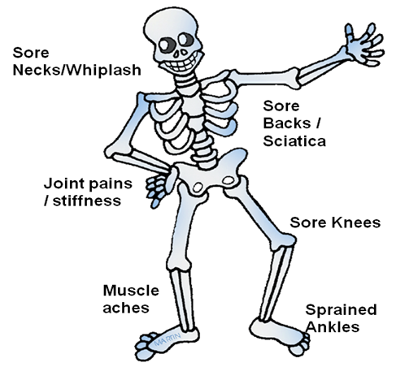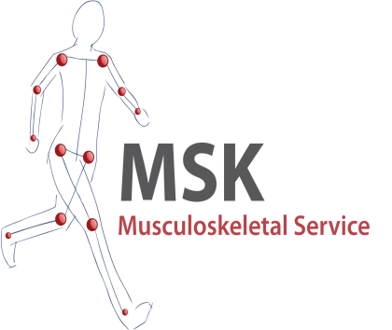

**Our Physiotherapist is in the surgery Thursday**

**Please speak to reception if you wish to make an appointment**

**(Appointments for physiotherapy assessment and advice only, you will be referred onward if any ongoing treatment required)**

**If the answer is YES:**

***We can offer you an assessment appointment with an advanced physiotherapist – you wouldn’t have to see your GP first.***

# Do you have a muscle bone or joint problem?

**Physiotherapy**

**Barns Medical Practice**

**40 Dalblair Road**

**AYR KA7 1UL**

**Tel: 01292 281439**

[**www.medicayr.com**](http://www.southbeachsurgery.co.uk)

We are excited to be able to provide you with a first person assessment.

Please speak to reception or call for an appointment.

For a course of physiotherapy you can still self refer to physiotherapy via the MATS Service – 0800 917 9390

# What do we do?

You can now book for an assessment with a musculoskeletal advanced practitioner physiotherapist in house at Barns Medical Practice

Our skilled physiotherapist will complete an assessment detailing the nature of the problem along with a physical examination.

You can then be provided with advice and maybe some simple exercises. You may need to be referred onwards for further investigation or a course of treatment if required.

#### Physiotherapy Assessment

#### At Your GP Practice

**Symptoms you may have:**

* Pain, sharp or dull
* Pain, tingling or numbness
* Stiffness
* Weakness
* Struggling with day to day activities
* Interference with your life or work

**MSK Physiotherapy is not appropriate for:**

* Children < 16 years
* Pregnant Women
* Patients requiring a home visit
* Patients requiring prescriptions or fit notes only
* Pain from non MSK cause, (ie. Cardiac, systemic infection)
* Headaches